JOB DESCRIPTION

POST: Network Officer
RESPONSIBLE TO: Programme and Insight Manager
SALARY: £21,000 - £28,000
HOURS: Full Time, 35 hours per week
HOLIDAYS: 28 days plus bank holidays pro rata
SPECIAL CONDITIONS: Flexible, occasional weekend and evening work is required.
To be based at a CAB&D Office with

ABOUT HERE 4 BDCC
Here 4 BDCC is a consortium of Voluntary, Community and Social Enterprise, (VCSE), Organisations working as a collaborative team across the Bradford and Craven Districts to ensure seamless infrastructure support services are provided to maximise the impact of resources in communities. We are committed to creating single point access and ‘no wrong door’ so VCSE organisations find services first time.
Our Vision: a diverse and vibrant VCSE that is becoming an increasingly significant part of the economic and social landscape. We want to see VCSE organisations taking a wider role in helping communities to own and manage the challenges and opportunities they face.
Our approach puts Bradford District and Craven communities at the heart of everything we do, wrapping seamless services around them and feeding their insight out to stakeholders.
We are committed to;
- be ambitious on behalf of and towards the VCSE in BDC
- be inclusive and treat all partners and beneficiaries in an equitable manner
- value people and communities
- value partnership and collaboration
- be open, honest and transparent
- listen, reflect and contribute
- be open to being challenge
- be respectful of partners at all times

STRUCTURAL CHART – HERE 4 BDCC

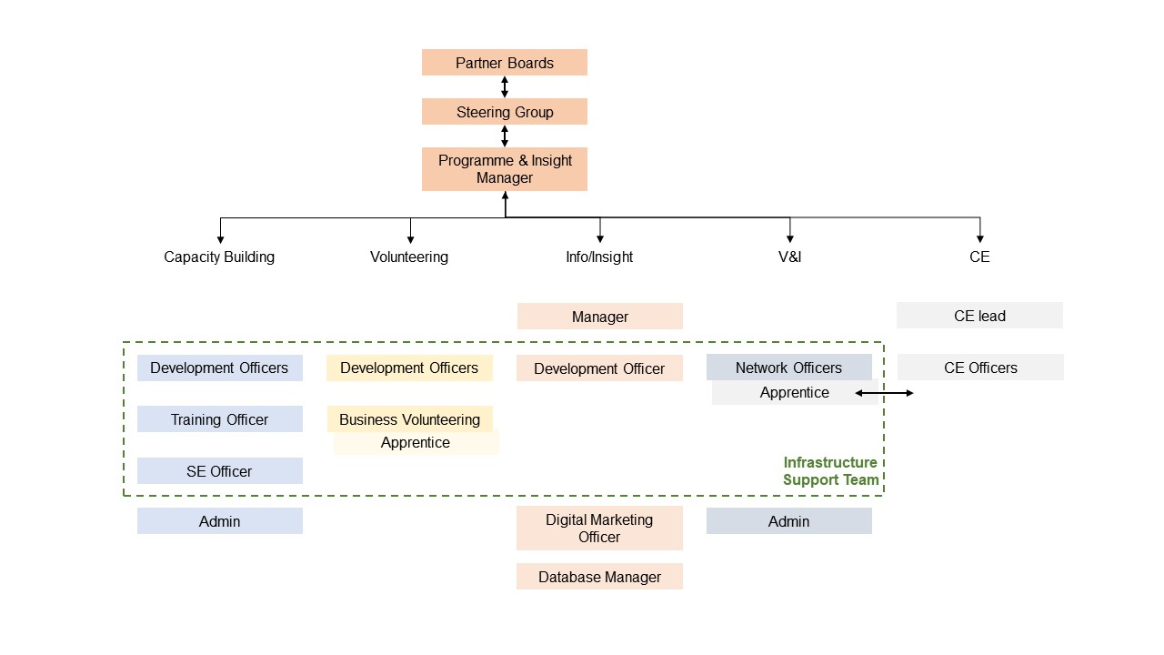
KEY PURPOSES OF THE POST
Working as part of a team, you will be responsible for ensuring that the diverse voices of the VCSE are heard and engaged in leadership and advocacy, representing the depth of communities in Bradford and Craven. You will be responsible for addressing barriers to the participation in voice and influence and developing and strengthening partnerships with a wide range of organisations in order for us to fulfil our vision.

MAIN DUTIES AND RESPONSIBILITIES

- To map, connect with, and support existing and emerging VCSE networks and partnerships, within Bradford District and Craven, nurture their work, including supporting activity to develop the voice of young people.

- Engage and work with local VCS groups actively and continuously seek the views of /from a diverse range of VCS organisations and groups to identify their key issues in shaping positive system change.

- Manage the selection, and appointment process for sector leaders. Support and brief the sector leaders, advocates and representatives using consistent intelligence and insight.

- Take a lead on one of the following specialisms; Safeguarding, Children and Young People’s, Health and Social Care Structures.

- Work across the matrix of Here 4 BDCC delivery partners and other key stakeholders to ensure seamless communications within infrastructure support, that maximises the of community resources.

- Support core networks by developing, co-ordinating and facilitating events, and disseminating key strategic information, ensuring appropriate networks are aware and understand current and relevant intelligence.

- Establish and support feedback mechanisms between Here 4 BDCC and it’s partner organisations, at the level appropriate.

- Contribute information and content for Here 4 BDCC and partner bulletins and social media communications.
- Ensure support to groups/individuals that experience disadvantage and/or discrimination, and address barrier to participation in Voice and Influence.

- Work with Here 4 BDCC and partner organisations, and wide stakeholders that collect or hold VCSE insight and ensuring that intelligence is being fed into relevant databases.

- Work to uphold the mission, values and objectives of Here 4 BDCC.

- Act as a representative of Here 4 BDCC and the VCSE sector in a range of meetings/settings and actively participate in making connections between the VCSE and external partners.

- Actively contribute to the priorities of Here 4 BDCC and activities to further develop the work of VCSE sector in Bradford and Craven.

- To carry out your own administrative tasks, and any other work, within reason, as agreed with your line manager.

SKILLS, KNOWLEDGE & EXPERIENCE
Requirement | Essential/  Desirable | Measurements
Experience of establishing, working with and supporting partnerships and networks of organisations and facilitating participation, including within minoritised communities | Essential | A/I
Experience of co-ordinating, presenting and minute taking for meetings and events | Essential | A/I
Experience and Knowledge of building relationships and leading on genuine member-led insight, with multiple stakeholder groups with differing cultures | Essential | A/I
Excellent written and oral communication and interpersonal skills required to collaborate with a wide range of internal colleagues and external stakeholders. To include creating content for briefings, social media, presentations, and the ability to summarise complex information in accessible ways | Essential | A/I
Active commitment to equity, diversity and inclusion | Essential | A/I
Highly IT literate – Ability to confidently use all current IT office software including Microsoft Excel to generate reports, presentations and develop effective business processes and input data into relevant databases | Essential | A/I
Knowledge and experience of working with the VCSE Sector | Essential | A/I
Knowledge of the geography, demographic and issues effecting people, communities, and the work of the VCSE in Bradford and Craven | Desirable | A/I
Specialist knowledge in some of the following areas:  - Children and young people’s services and structures  - Health and social care services and structures  - Safeguarding | Desirable | A/I

EQUAL OPORTUNITIES

CAB&D is committed to equal opportunities, anti-discrimination and anti-oppressive policy and practice. No one we have contact with may be discriminated against either
directly or indirectly on the grounds of gender, race, nationality, ethnicity, religion, marital status, sexual orientation, age or impairment. This policy applies to job applicants, employees, volunteers and service users.

NOTES

All jobs are subject to change from time to time and this job description will be reviewed regularly.

The job description is a guide to the work that you will be required to undertake and represents a range of responsibilities in line with the grade for the post.

The post-holder must work in line with CAB&D’s Code of Conduct and to maintain good relationships both internally and externally.

The post-holder must comply with all organisational policies and procedures.

This post is subject to a 3 month probationary period.

